**Geometric Mid-Century Wall Art**

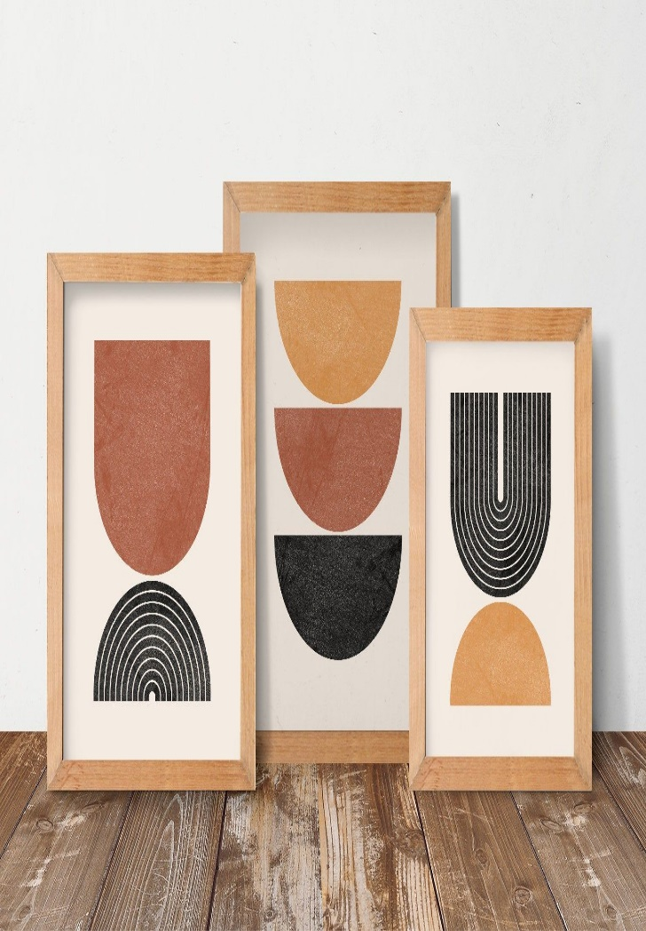 Geometric mid-century wall art captures the essence of mid-century modern design, which emphasizes clean lines, bold shapes, and a harmonious balance between form and function. Typically featuring geometric patterns like circles, triangles, squares, and abstract compositions, these artworks incorporate vibrant, retro-inspired color palettes—often blending muted tones with pops of bold primary colors like red, yellow, and teal. The design is minimalist yet striking, creating a sense of movement and sophistication. Perfect for living rooms, dining areas, or offices, geometric mid-century wall art brings a touch of vintage charm with a modern twist, enhancing interiors with a timeless, artistic flair. Its simplicity and elegance make it a versatile addition to any contemporary or retro-inspired space..